Executive Summary

In 2026, the world passed an important milestone: more than 10% of the ocean is now reported as protected or conserved, up from 8.6% in 2025.
However, progress remains far off track from the global target to protect and conserve at least 30% of the ocean by 2030 (30x30). At the recent historical pace, global coverage would reach only around 15% by 2030, halfway to the target. The expansion of marine protected and conserved areas is also not yet matched by the conditions needed to deliver effective implementation. Only 3.5% of the ocean is assessed and deemed to be effectively protected.
Implementation is the defining challenge for the remaining four years to 2030. As ambition has increased, countries should continue to ramp up designation, but also ensure those areas are effectively managed, financed, enforced, equitably governed and delivering measurable outcomes. New analysis by SkyTruth for this report, using data from the Marine Conservation Institute, shows that while protection of key marine habitats is relatively high on paper, only a small share is assessed as being effectively protected: 33% of mangroves are reported as protected, but just 0.3% are fully or highly protected; for seagrass the figures are 34% and 1.1%, respectively; and while 47% of warm-water corals fall within protected areas, less than 10% are fully or highly protected.
The implementation gap is even more acute on the High Seas, where less than 2% is protected today, and less than 1% is assessed and found to be fully or highly protected. Making up nearly two-thirds of the global ocean, achieving 30x30 will not happen without protecting the High Seas. The first generation of High Seas marine-protected areas (MPAs) will be a test of whether countries can translate ambition into effective conservation measures on the water. It will be critical to ensure that early High Seas MPA proposals include the conditions necessary to be effective, rather than repeating the same gap seen in national waters. There is no time to create a new generation of paper parks on the High Seas.
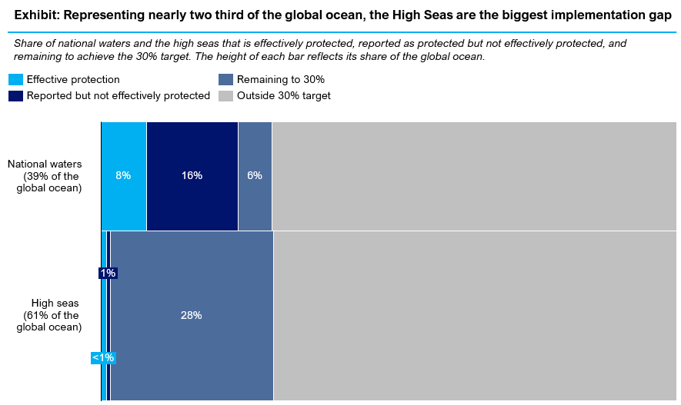
Updated visual:
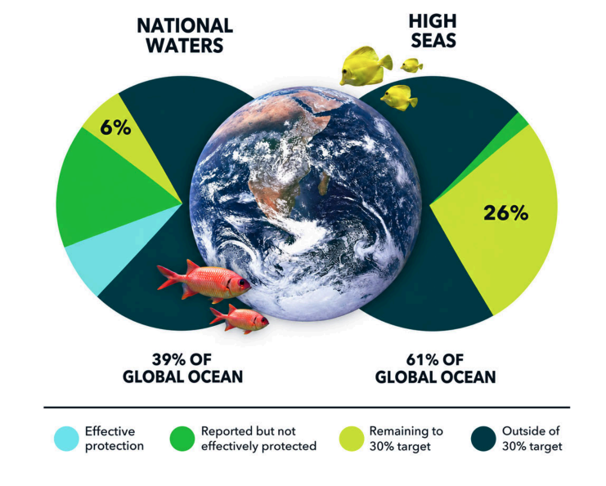
Countries are showing that effective protection is possible, but it requires more than designation alone. Examples from Chile, Palau and elsewhere demonstrate that ocean protection can be successful if underpinned by effective governance, long-term finance, community leadership, enforcement and monitoring.
Nearly half of coastal countries now have quantified 2030 national ocean protection targets, but ambition must now be matched – and exceeded - by implementation. Current national targets could achieve [26]% protection of national waters by 2030, but many countries have yet to translate these commitments into effective protection. A quarter of countries with a quantified 2030 target do not yet protect or conserve any of their waters, and nearly half have only protected 5% or less.
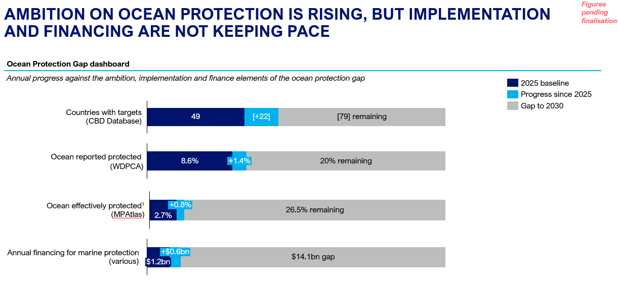

Effective protection and conservation carries substantial economic returns. Previous analysis identified at least US$85 billion in potential annual economic benefits by 2050 from healthier fisheries, coastal protection and conserved blue carbon ecosystems. At the same time, weak protection also carries measurable costs. Illegal, unreported and unregulated fishing is estimated to cause US$23.5 billion in annual losses globally, while bottom trawling in European waters, including within many MPAs, imposes environmental costs estimated at up to €16 billion a year. ,
Current financing for marine protection is estimated at around US$1.8 billion a year – approximately a tenth of what is needed to deliver 30x30. Annual investment in marine
conservation is equivalent to just one month of the US$22 billion governments spend each year
subsidising harmful marine activities. Closing the finance gap will require greater domestic funding alongside international finance, philanthropy, and private capital.
The High Seas Treaty offers the clearest opportunity to change this trajectory. The Treaty entered into force in January 2026, ratified by 94 parties. The Treaty creates, for the first time, a global mechanism for establishing area-based management tools, including MPAs, in the 61% of the ocean beyond national jurisdiction. Without rapid progress on the High Seas, achieving 30x30 is all but impossible. In a complex environment for multilateral collaboration, the entry into force of
the Biodiversity Beyond National Jurisdiction
(BBNJ) Agreement is a bright spot that offers a real opportunity for constructive engagement.
Delivering effective protection is achievable. Investing in the conditions that enable implementation will be key to determining whether 30x30 delivers meaningful conservation outcomes or protection only on paper. These conditions include:
- Durable finance. Long-term, sustainable financing is essential to support management, monitoring, enforcement and community-led stewardship. Domestic finance will need to provide the bulk of ongoing management costs, which requires putting ocean protection higher up on finance ministers’ agenda, but international funding, philanthropy and the private sector all have roles to play.
- Open data and transparency. Accessible data, monitoring systems and public reporting are critical for accountability, enforcement and informed decision-making.
- Equity, inclusivity, and a human rights-based approach. Effective protection and conservation must recognize and support the rights, leadership, knowledge and stewardship of Indigenous Peoples and local communities.
- Effective management and enforcement. Protected and conserved areas require clear objectives, robust management plans, effective compliance systems and sufficient institutional capacity to implement protections in practice.
CBD COP17 and BBNJ COP1 must mark the shift from ambition to implementation. We know what effective protection and conservation look like, and there is growing evidence that the long-term ecological, social and economic benefits can far exceed the costs of action. Governments should arrive ready to strengthen national commitments, secure sustained financing for long-term management, redirect harmful subsidies and lay the foundations for the first generation of effectively managed High Seas MPAs under the BBNJ Agreement. The measure of success is no longer only how many hectares of protection are announced, but how much ocean is genuinely protected, conserved, financed and delivering outcomes for people and nature.

SkyTruth analysis using Protected Planet data on reported protection and the Marine Conservation Institute’s MPAtlas data on fully/highly protected areas, and habitat extent layers from UNEP-WCMC and Global Mangrove Watch. See footnote XX for methodology and full list of sources.
Protected Planet, MPAtlas
Based on protection as reported to WDPCA / Protected Planet
Together for the Ocean, Ocean Protection Gap, 2025
Agnew et al. 2009
Katherine D. Millage, Juan Mayorga, Sara Orofino, Trisha B. Atwood, Alan M. Friedlander, Louise S.L. Teh, Maria L.D. Palomares, U. Rashid Sumaila, Enric Sala, The value of bottom trawling in Europe, Ocean & Coastal Management, Volume 278, 2026
This report uses the term “High Seas Treaty“ as short-hand for The Agreement under the United Nations Convention on the Law of the Sea (UNCLOS) on the Conservation and Sustainable Use of Marine Biological Diversity of Areas beyond National Jurisdiction, which is known as the BBNJ Agreement or High Seas Treaty. We acknowledge that the scope of the BBNJ Agreement encompasses all Areas beyond national jurisdiction, including the seafloor and water column. This choice of wording is intended to ease understanding for broad audiences and does not convey a prioritization among the components or principles of the BBNJ Agreement.
Correct at the time of publication
The conditions set out here are critical to ensuring that individual protected areas deliver their intended conservation outcomes but do not represent all factors relevant to achieving Target 3 at the system-level, including ecological representativeness, connectivity and coverage of areas of particular importance for biodiversity and ecosystem functions.

